**React Tutorial for Beginners - Mosh**

**----- What is REACT?**

--- React is a JS library for building a dynamic and interactive user interface.

**----- Creating a REACT App**

--- Tools to create a REACT Application

* Create REACT App (CRA)
  + npx create-react-app my-app
* Vite
  + npm create vite@latest

npm run dev

**----- REACT Ecosystem**

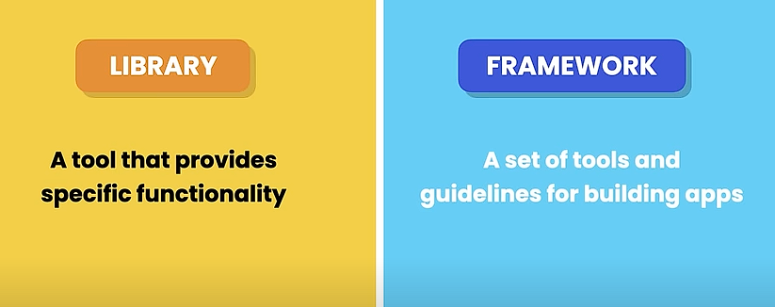

**----- Building Components**

**--- Creating a List group**

* Install Bootstrap
  + npm i bootstrap@5.3.3

lesson6